Date:24/10/2026
ITA-0329:Mobile Computing
CO2
AT2-Experimentation
S.Dinesh
192311302
1.)Mobile IP Communication Work Flow:

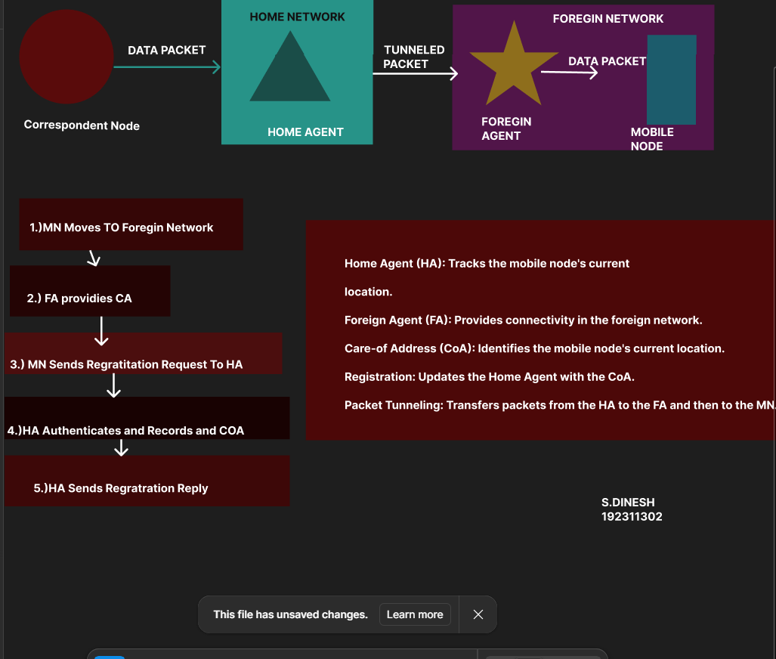

2)Cellular Network vs Manet(Smart City):

